**India’s Agricultural Crop Production Analysis (1997-2021)**

**1.Introduction:**

Agriculture Sector is changing the social-economic environments of the population due to liberalization and globalization. About 75% people are living in rural and are still dependent on agriculture. About 43% of India’s geographical area is used for agricultural activity**.**

**1.1.Overview :**

Agriculture is the backbone of the Indian economy. Around 58% population of India depends on Agriculture. Its gross irrigated crop area of 82.6 million hectares (215.6 million acres) is the largest in the world. India is among the top three global producers of many crops , including wheat , rice , pulses , cotton , fruits and vegetables.

**1.2.Purpose:**

Agriculture is the foundation of the Indian economy . The population of india mostly depends on agriculture for their livelihood and agriculture contributes to 40% of the total GDP of the country. Agriculre impacts society in many ways.

**2.Problem Statement:**

Small and fragmented landholdings , a lack mechanization , soil erosion , agricultural marketing , and insufficient storage facilities are the main problems in indian agriculture.

**2.1.Empathy map:** 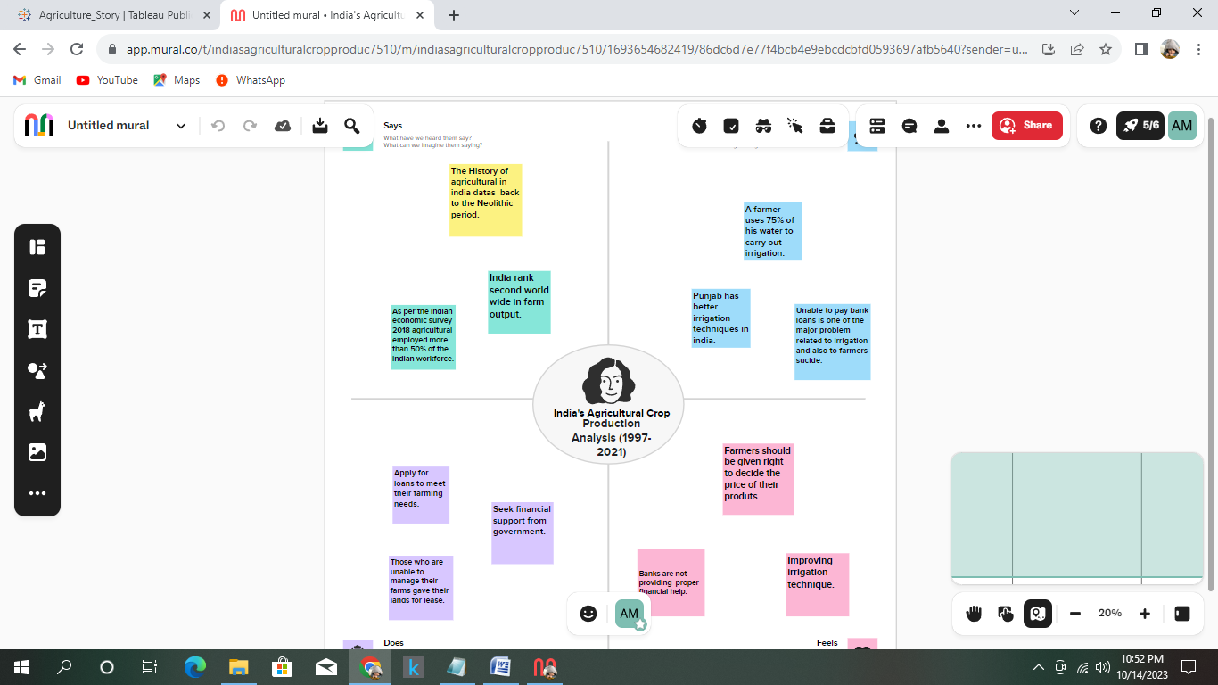

**2.2.Ideation and Brainstorming map:**

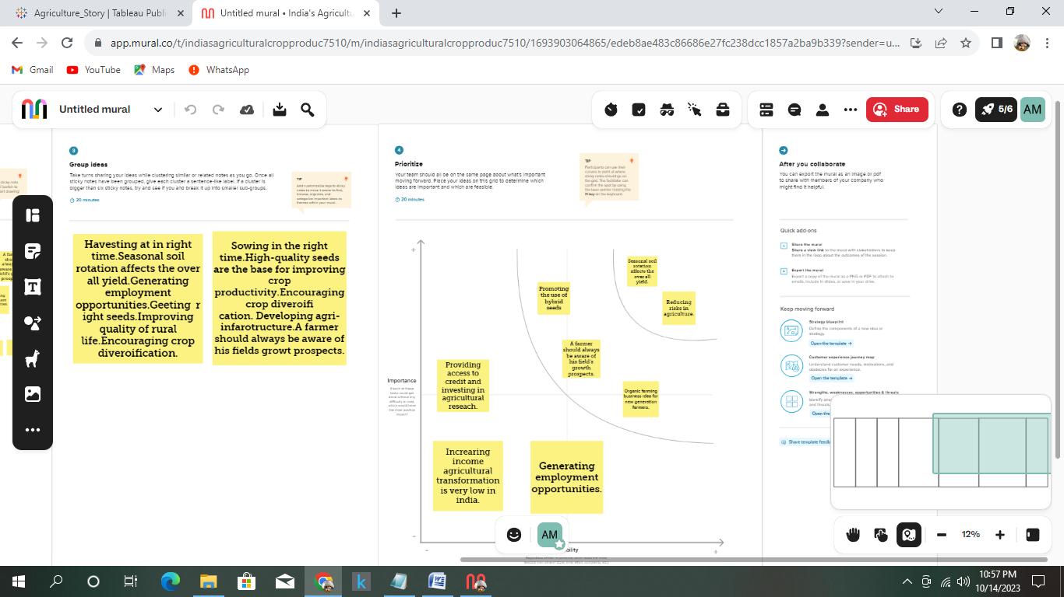



**3.Result:**

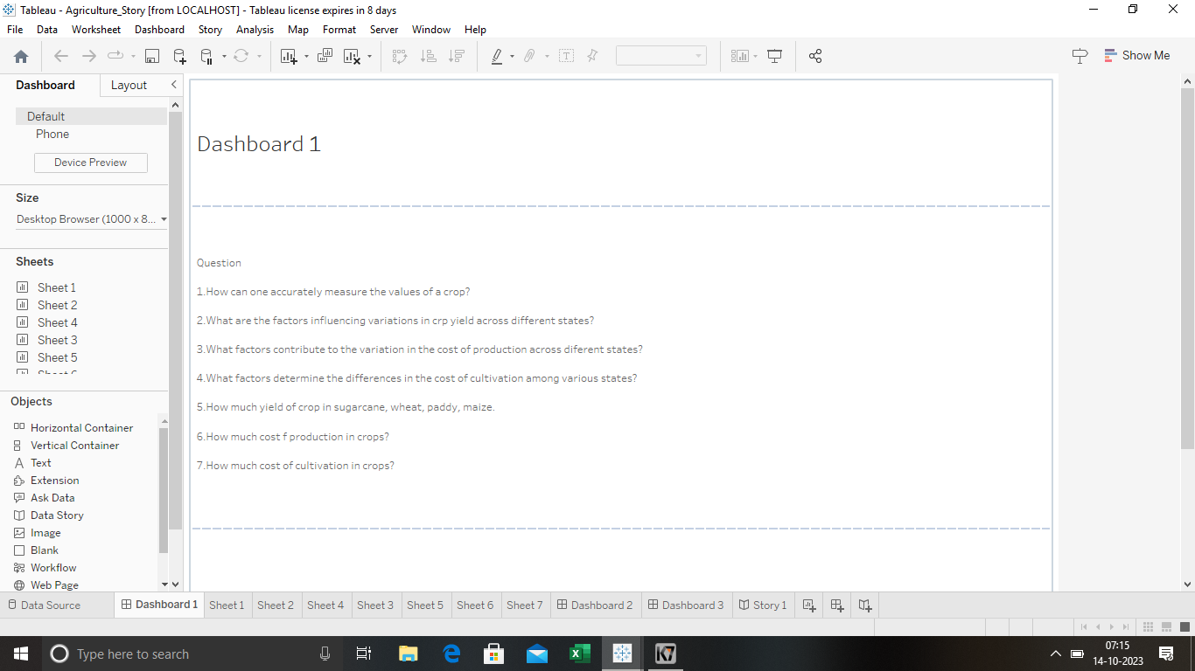

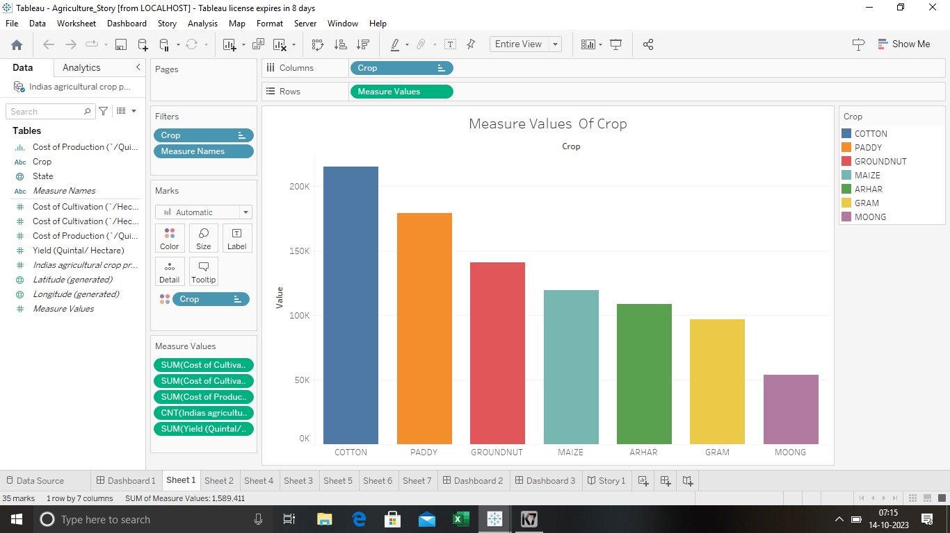

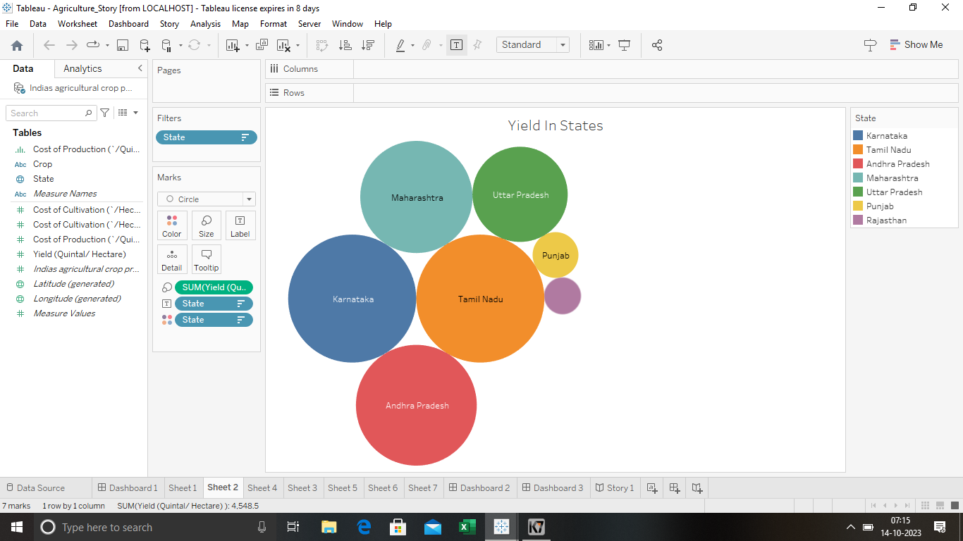

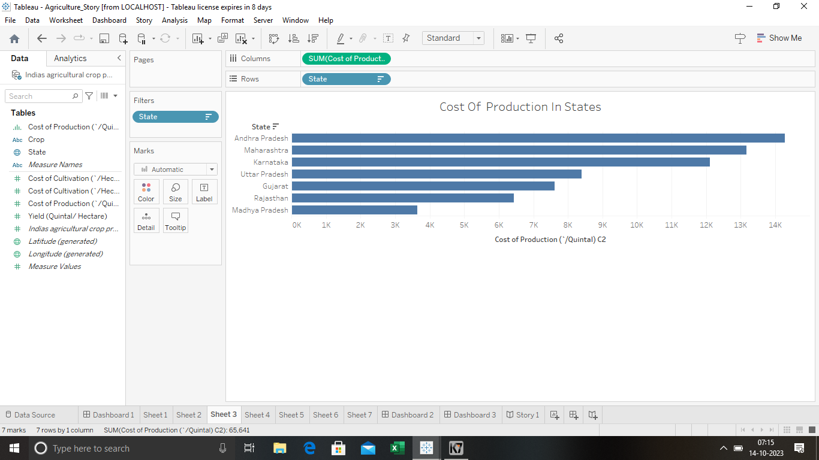

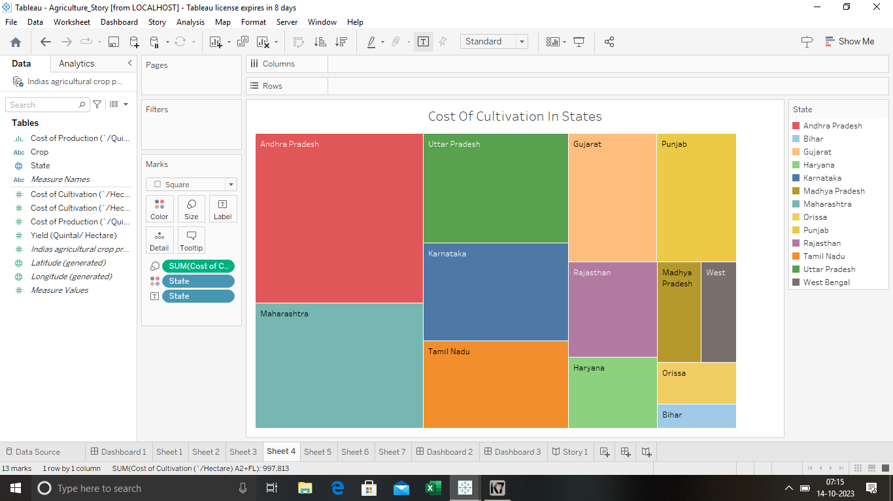

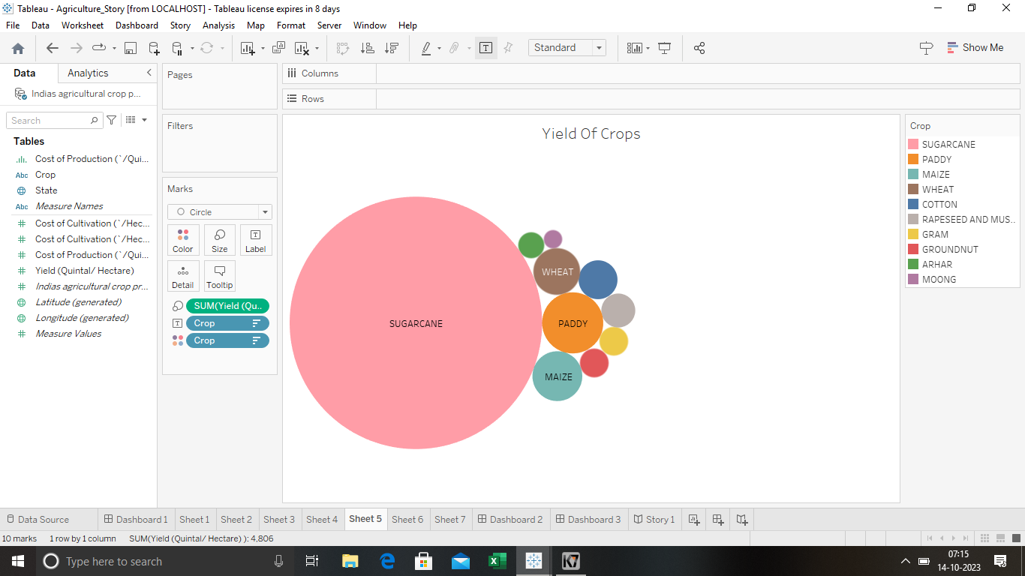

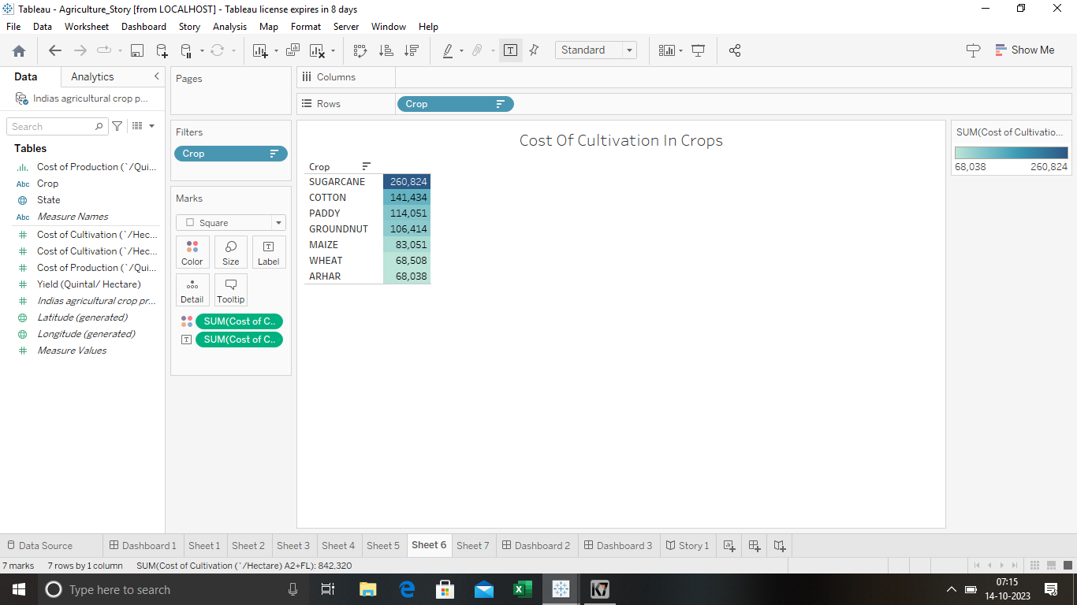

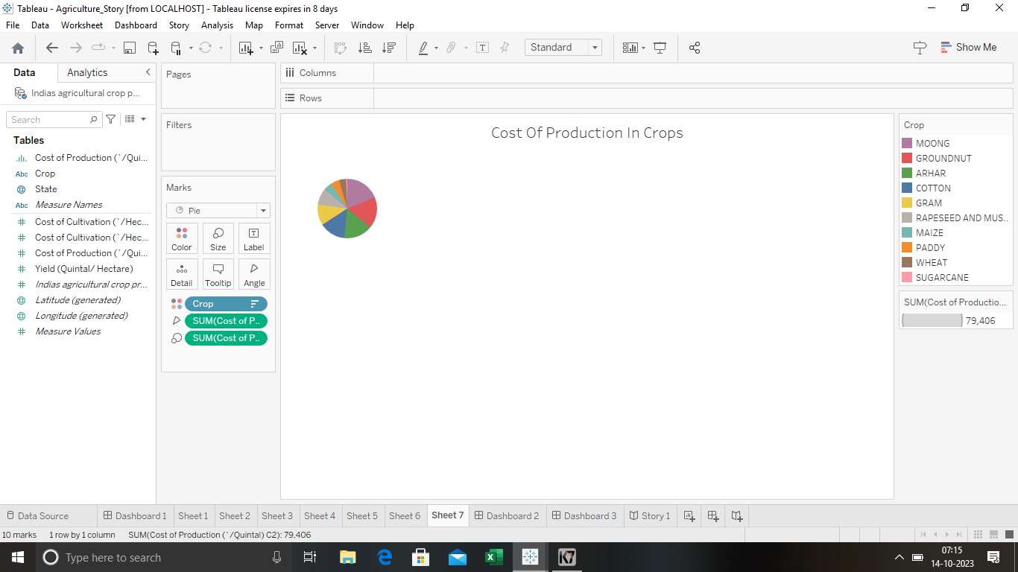

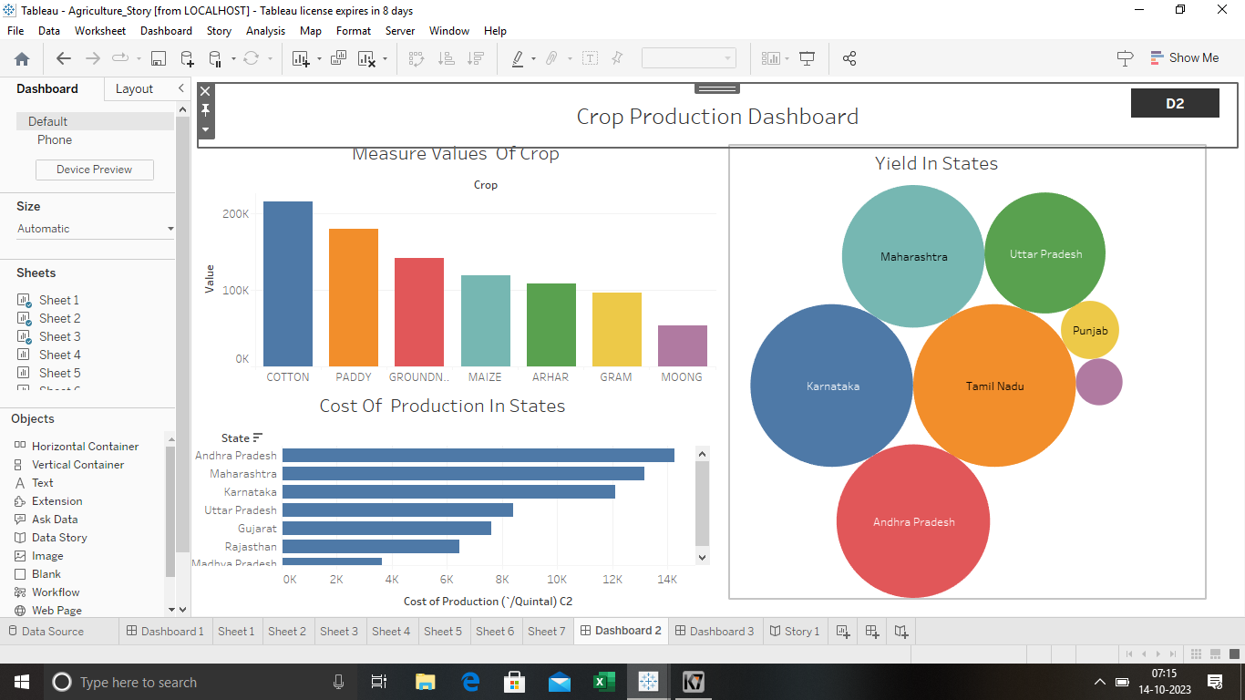

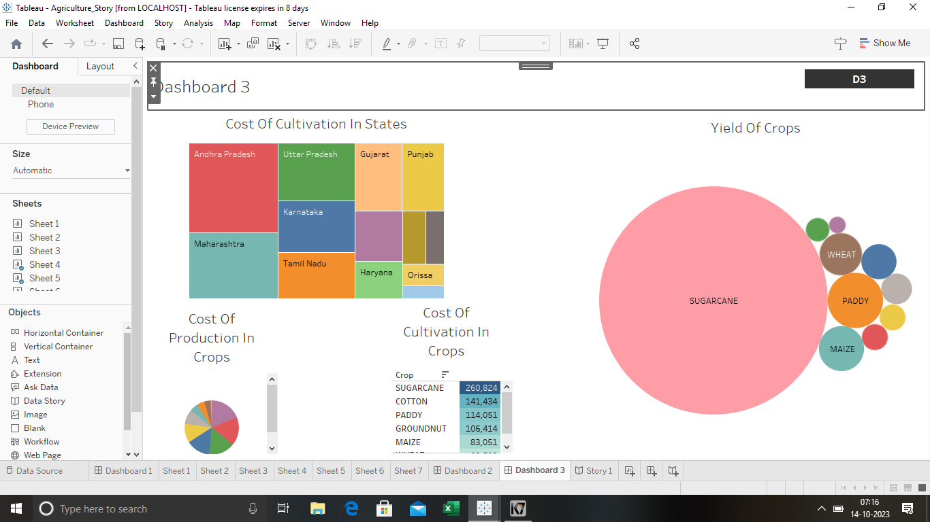

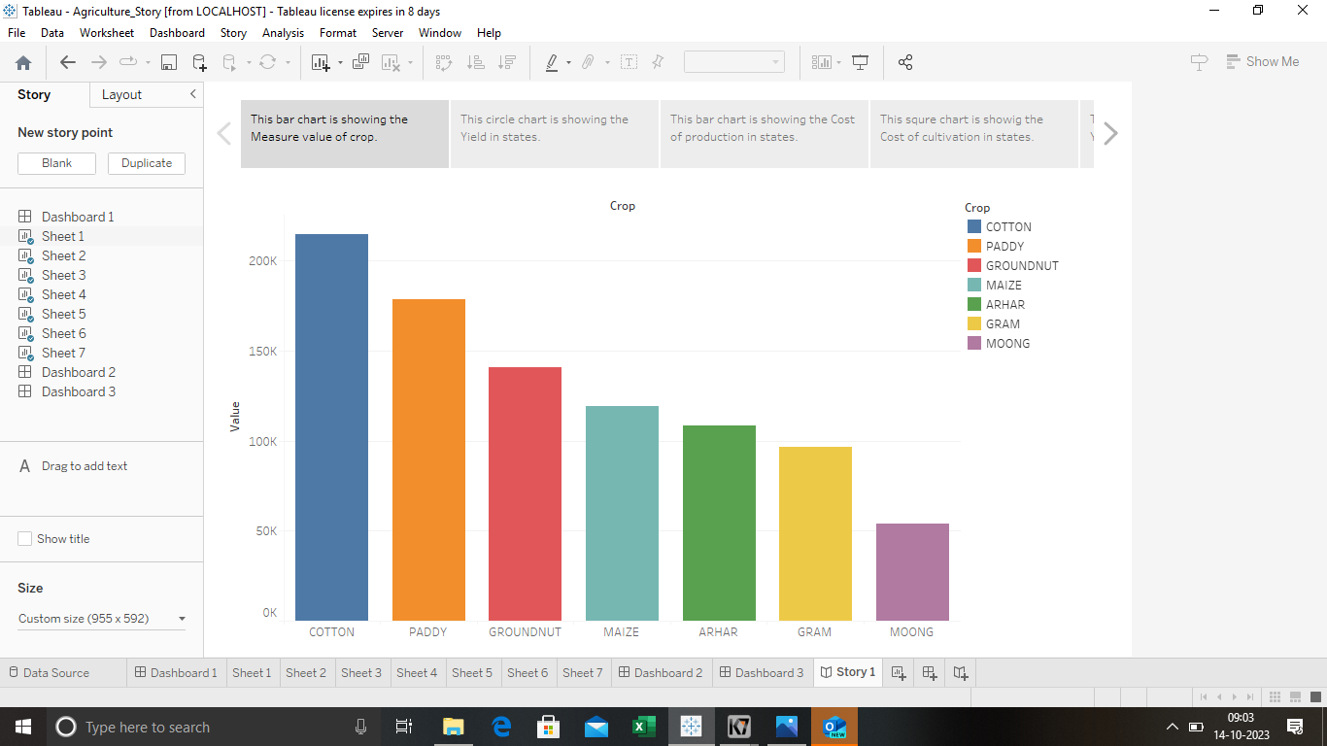

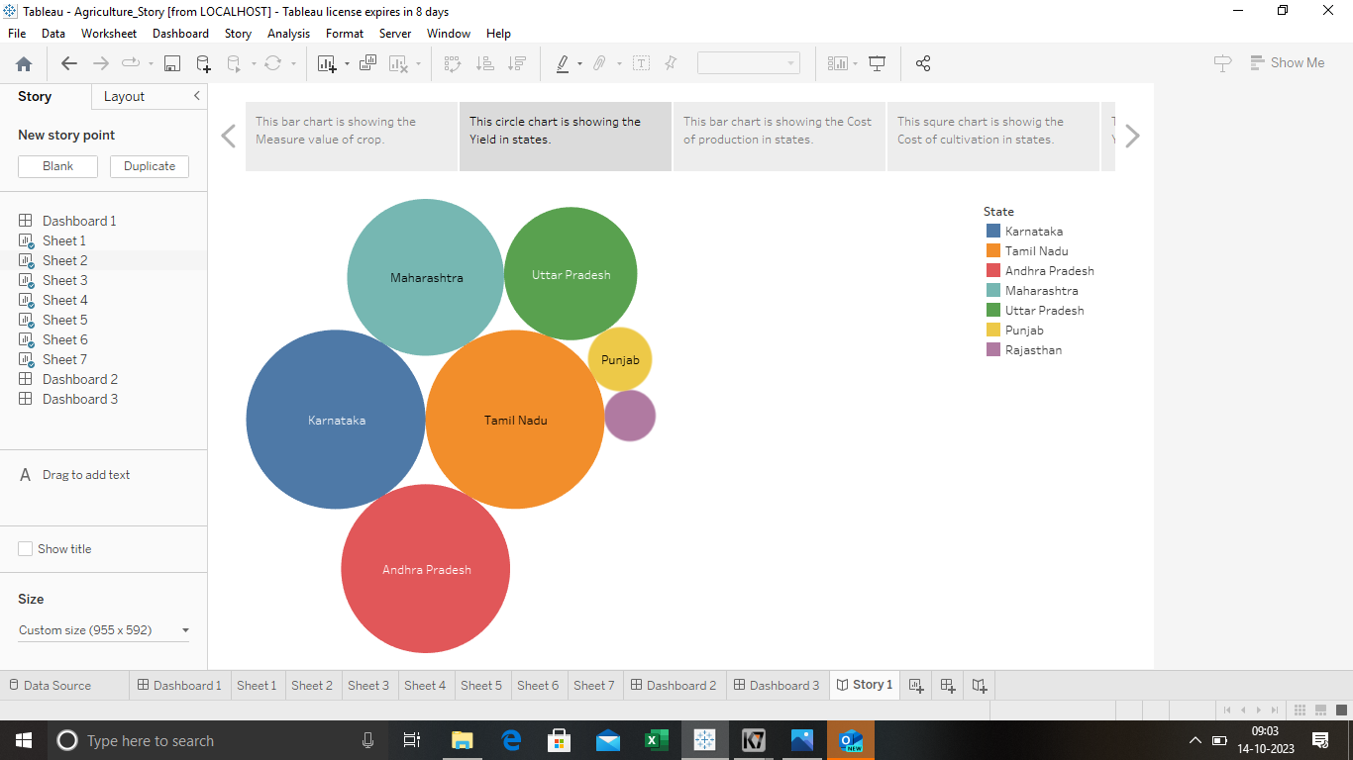

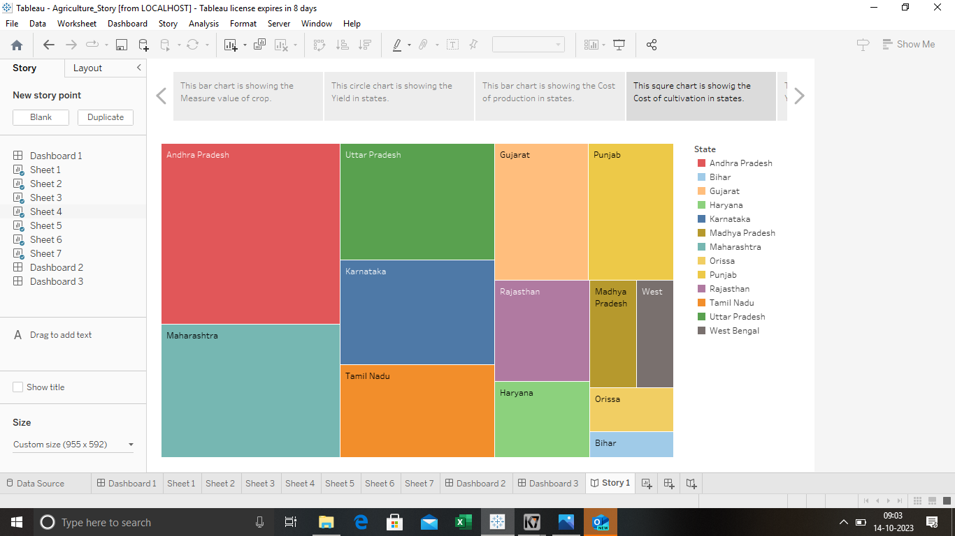

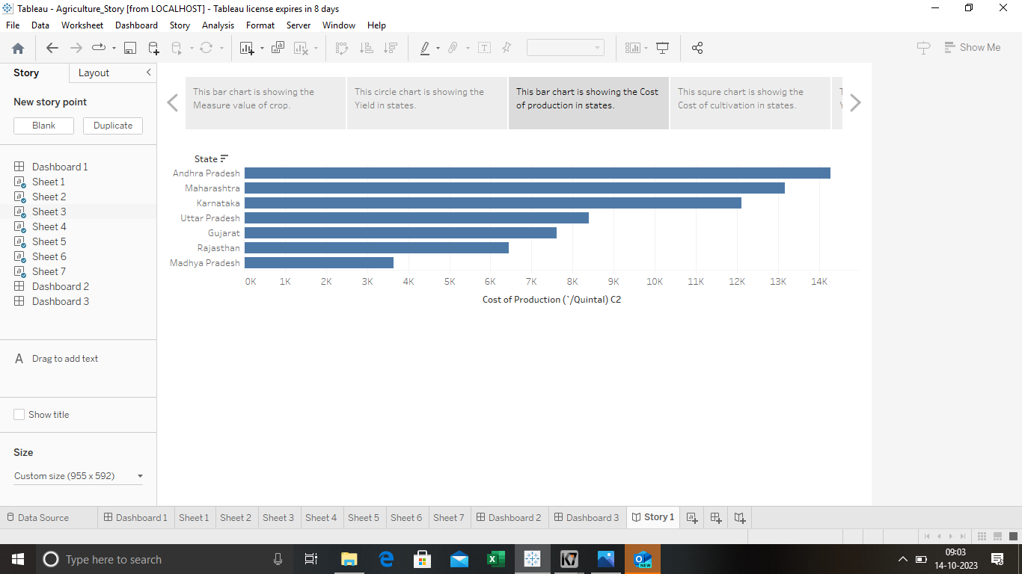

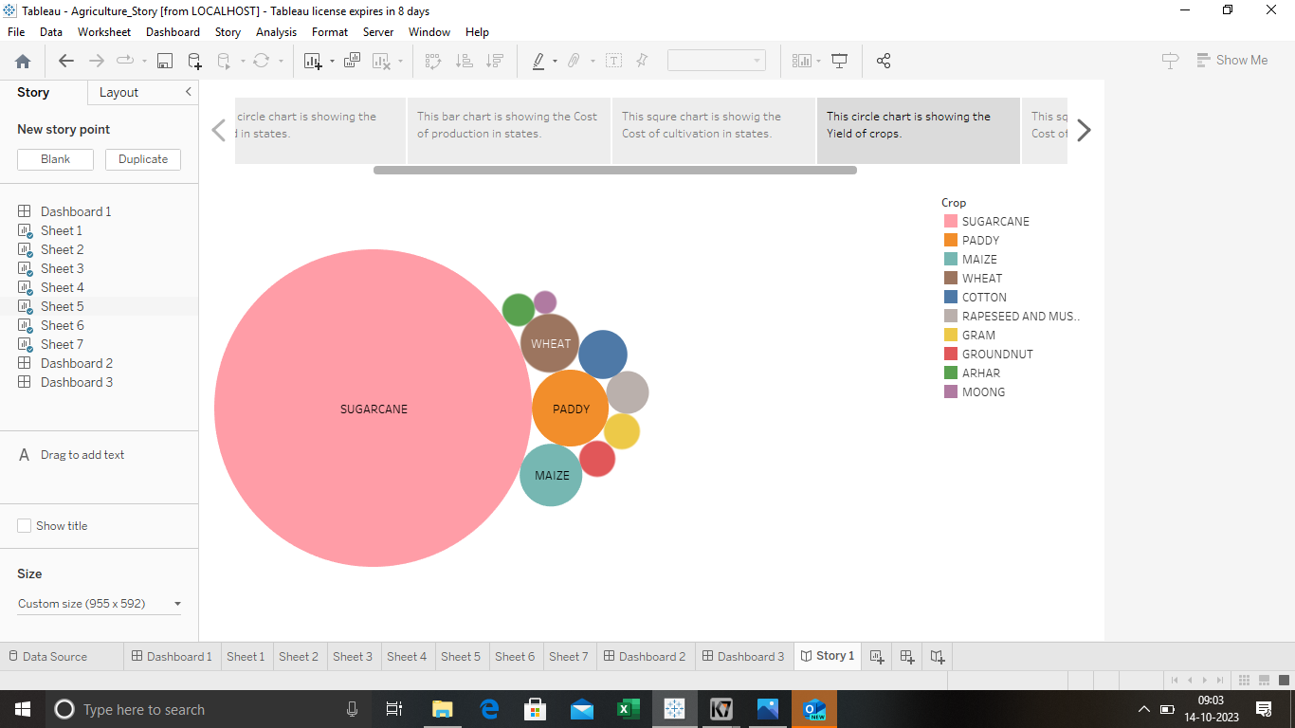

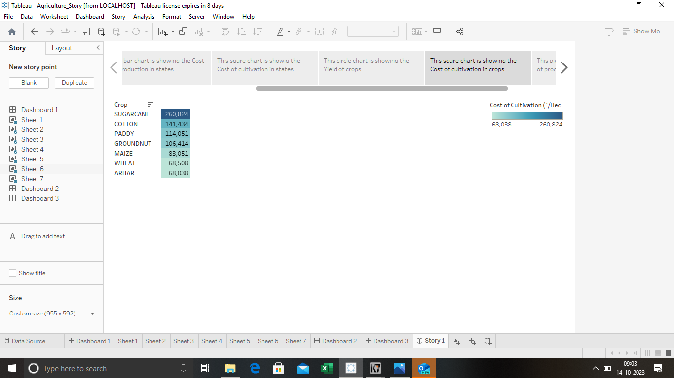

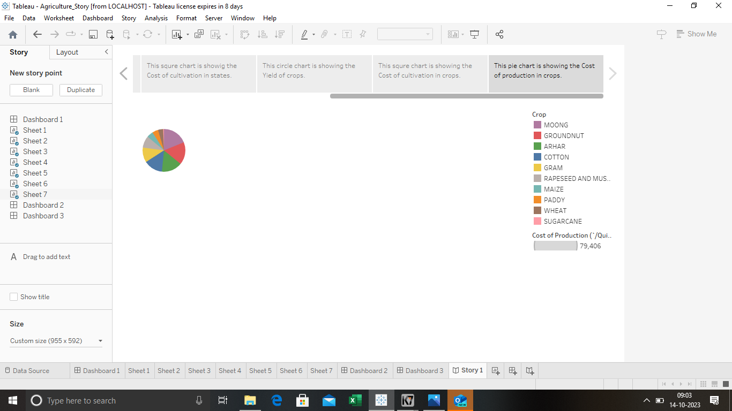

**4.Conclusion:**

India has always been benefited by Agriculture. Thus the agricultural sector is playing a very important role in the country like india and the prosperity of the Indian Economy still largely depends on agricultural sector.

Agricultural development is the basic pre condition of sectoral diversification and development of the economy.